**DOC-001 - Provide Architecture diagram designed with scalability and high availability**

**General Objective:**  
To design and implement a solution on AWS that allows migrating the customer's current workloads, including website and databases, improving the performance and availability of the service.

This solution must allow the customer to stay competitive in a constantly growing market.

Infinity Gifts Souvenirs is a company from the Dominican Republic and seeks to guarantee access to its online store securely through a solution deployed on AWS

The architecture used for the implementation of Infinity tool has the following main components:

* Microsoft SQL Server Database
* Microsoft IIS Server
* Microsoft Active Directory
* Elastic Block Store
* Elastic Load Balancer
* Certificate Manager
* Route53
* WAF
* Systems Manager

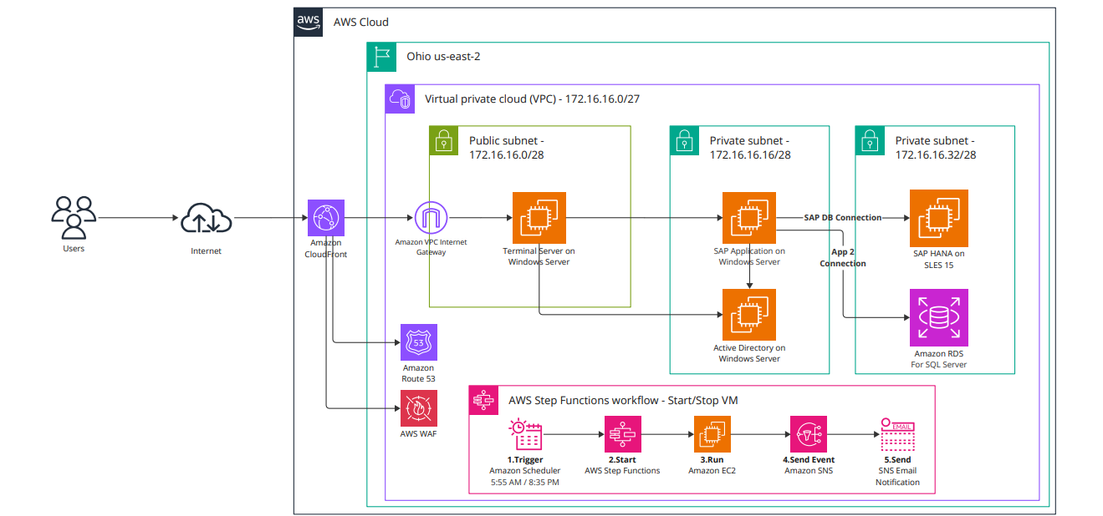

The solution is currently deployed in the us-east region at the request of the Infinity Gifts Souvenirs technical team.

The decision to work in a single Availability Zone is due to the requirement to reduce the operating costs of that solution.